GENERAL DONATIONS

Mr. & Mrs. Ed Strogoff Mr. & Mrs. Rick Pickering
Mr. & Mrs. Arthur Goldberg Barbash Associates Inc.
Ms. Shirley Nixon Mr. & Mrs. David Hazlett
The National Grand Bank Mr. Jody Shaw – Ballymeade CC
Marblehead Savings Bank Volk Packaging volkboxes.com
Mr. & Mrs. Larry Zimble Mr. Matthew Dworman
Judy Schwartz – JAS Associates Mr. & Mrs. Bill Mishkin
Mr. & Mrs. Sam Shindler Mr. & Mrs. Norman Jepsky
Mr. & Mrs. Alvin Fagan Cramer Products, Inc.
Watkins Motor Freight Mr. & Mrs. Charles Levine
Mr. Herb Ablow Mr. Stephen Hunt
Mr. & Mrs. Norman Mais Mr. & Mrs. Bill Cowtan
Mr. & Mrs. Irving Weisman Mr. David Cudlipp
Jane Fucci – Danzas AEI Mr. & Mrs. Malcom Finks
Mr. & Mrs. Marshall Hoffman Mr. David Fay
Mr. & Mrs. Neal Goldman Mr. & Mrs. Howard Gorney
Mr. & Mrs. Barry Turkanis Mr. & Mrs. Michael Waldman
Mr. & Mrs. Allen Schiller Mr. Joel Livingston
Mr. & Mrs. John Zahn Mr. & Mrs. Bruce Gordon
Mr. & Mrs. Peter Rosenberg Mr. & Mrs. Stuart Levine
Mr. & Mrs. George W. Pickering III Mrs. Carla Johnson
Mr. & Mrs. Marshall Hoffman Dr. & Mrs. David Winograd
Mr. & Mrs. David Cudlipp Mr. & Mrs. Bruce Goodman
Mr. Peter Hoffman The Sagan Family
New Penn Freight Mr. & Mrs. Marshall Sterman
Mr. Parker Livermore Mr. Rick Ledbury
Mr. Wayne Attridge

Team Photos Courtesy of:

Photo Swift

Marblehead, MA
Tel (781) 639-0200



June 24th, 2002

Gannon Municipal Golf Course
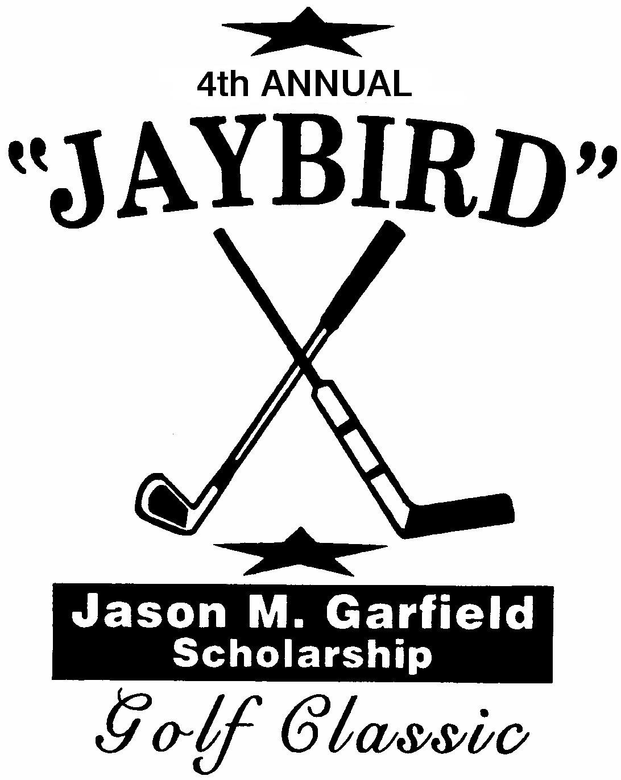

2002 Jason M. Garfield Scholarship Award Winner:

Elizabeth Teal VanSaun

Marblehead High School Class of 2002

Attending: The College of Charleston

Current Recipients:

2001 Ericka Frumes - George Washington University
2000 Alexis Delaney - Fairfield University
1999 Joshua Haskins - University of Wisconsin
1999 Talia Raviv - Northwestern University

SPONSORS

Jest Textiles, Inc.
Minuteman Press of Beverly & Danvers
Emtex, Inc.
Myra Feldman & Paul Gulko
C.L. Hauthaway & Sons Corp.
Nautilus Plus II, Inc.
Sagan & Company, CPAs, P.C.
Willow Street Medical Center
Gerry Donovan – Northwestern Mutual Financial Network
Topline Automotive LLC
The Zimble Family
Bob & Lynne Saltz
Sharon Livermore - Hunneman Tel. (781) 631-2026
Marblehead Youth Hockey
Bruce Rafey Associates, Inc.
Brian & Nicole Davis, Nicholas Harvell & Adam Drizen
Gelb & Gelb LLP – Counselors at Law
Mr. Peter J. Donovan
AMBRA Technologies LLC – Norman Lamoureux
Tri City Sales
Eastern Bank
Hero Coatings, Inc.
Lake HVAC – Donna Pariseau
The Pickering Family
Steven, Polly & Aaron Emery & Louise Shindler
Jaybird & Mais Inc.
Winwar’s Express, Inc.
The Frontero Family
Ralphco, Inc.
Freedman Eye Center
Mr. & Mrs. Harvey Karp
Rachel & Jacob Garfield & Justin Lebovitz
The Garfield Family
Don Corbett Real Estate

Today’s Program

Shot Gun Start 9:45am
Format: 5 Person Scramble

Maximum Mulligan’s Per Player: Two (2)
$5.00 per Mulligan

Hole #6 – Par 3
Hole-in-one car sponsored by: IRA MOTOR GROUP

Hole #14 – Par3
Closest to the Pin

Hole #9 – Par 3
Hole-in-one car sponsored by: DANVERS MITSUBISHI

Following Golf
Pick Up Winning Raffles at Table
Cocktails/Dinner

Team Prizes
Total Field
1st Place Gross
1st Place Net

Women’s
1st Place Gross
1st Place Net

Men’s/Mixed
1st Place Gross
1st Place Net

Each team is eligible for only one winning prize

