P. O. Box 206  Marblehead, MA 01945-0206 • USA  Contact: Scott Garfield – e-mail: scott@jaybird.com  Contact: Joe Pickering – e-mail: joe@searchprofessions.com | Jason M. Garfield Scholarship Fund, Inc.
Press Release
Burns awarded 2006 Jason M. Garfield Scholarship
Marblehead High School Senior headed to UNH to continue secondary education with focus on the graphic arts field.
Marblehead, MA – August 1st 2006

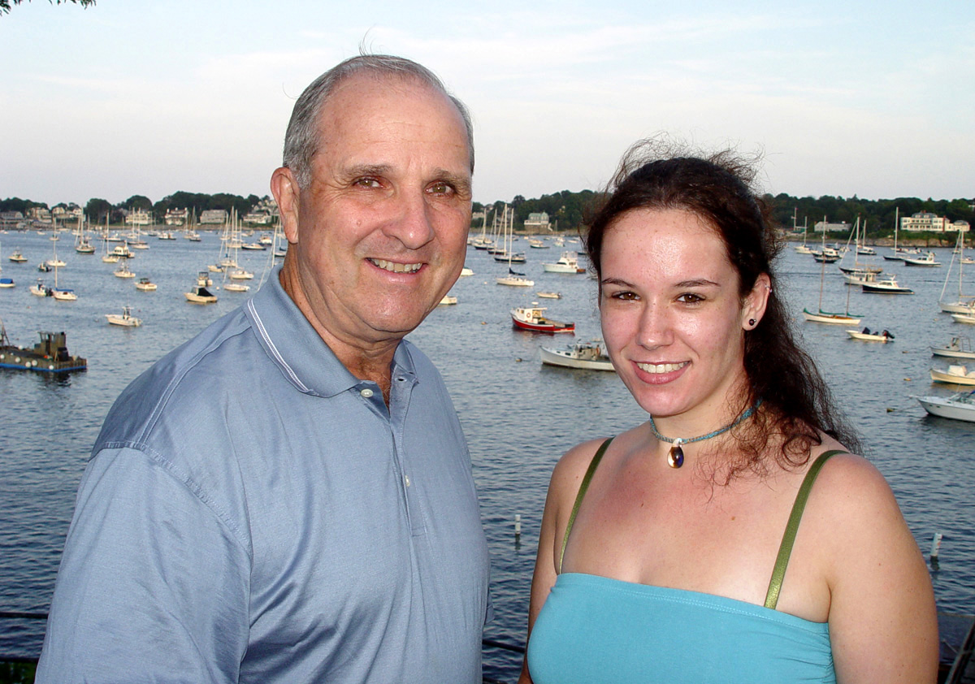
The J.M. Garfield Scholarship Fund is pleased to announce Robin Burns as the 2006 Scholarship recipient. This is the 22nd - $4,000 Scholarship awarded since the inception of the fund in 1983. Robin has been accepted to the University of New Hampshire in Durham. As a dedicated artist, Robin will continue her studies in the field of graphic arts. Robin was a four-year student at Marblehead High School with a grade point average of 3.2. While attending M.H.S., Robin was also active in the Art and International clubs, and volunteered her time to the town of Marblehead’s D.A.R.E. (Drug Abuse Resistance Education) program. These and various other impressive activities identified Robin as a strong applicant to the 2006 scholarship committee. In addition, Robin has shown the ability to overcome many personal obstacles which has made her a standout member in our community.

Ms. Robins Burns accepting her scholarship award from fund president - Joe Pickering

The Jason M. Garfield Scholarship Fund, Inc. is a scholarship fund named in honor of the late Jason Garfield who passed away in 1983 after a difficult and courageous fight with Leukemia. The Scholarship awards four (4) year grants to Marblehead High School graduating seniors who have overcome difficult obstacles in life, continues to make a difference in society and desires to continue their education beyond High School.

